3.47: a) The acceleration is
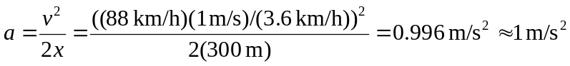
b) 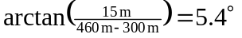. c) The vertical component of the velocity is 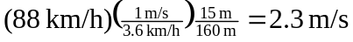. d) The average speed for the first 300 m is 44 km/h, so the elapsed time is
or 31 s to two places.

